# Week 2 Typescript

## Lesson 2

Video tutorial: <https://youtu.be/mYRvb_nGQRs>

[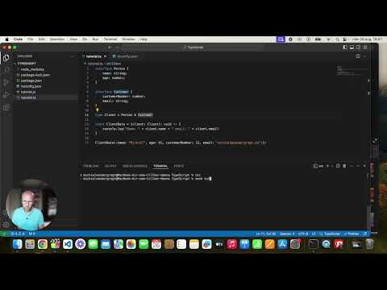](https://youtu.be/mYRvb_nGQRs)

### Instructions:

Convert the Shopping Cart Code to TypeScript

I have uploaded a Javascript file here:  
<https://github.com/mvdgragt/BackEndDeveloper/blob/master/shoppingCart.js>

Your goal is to change this file into a TypeScript file called shoppingCart.ts.

Please create your own Repo on GitHub and call it ShoppingCart.js. Add this file to your repo.

Turn this file into a typescript file using what you have learned so far.

If you want to check how to do it step by step. Check the next pages!

Submit the link to your repo here:

My Repo:

https://github.com/Onksami/ShoppingCart.js..git

_______________________________

Feedback completed by the teacher:

# Explanation

#### Copy the JavaScript Code

* Open shoppingCart.js and select all the code (you can press Ctrl + A to select all).
* Copy the selected code (you can press Ctrl + C to copy).
* Now, open shoppingCart.ts.
* Paste the copied code into shoppingCart.ts (you can press Ctrl + V to paste).

#### Convert the Categories Object to a TypeScript

Find this part of the code:

#### 

Change it to:

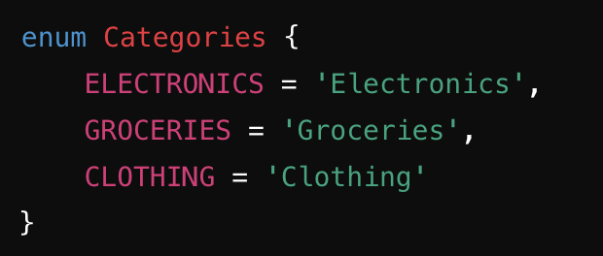

#### Create a Product Interface

Find this part of the code:

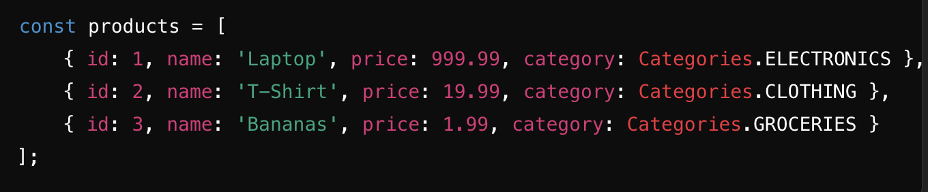

Before this code, add the following:

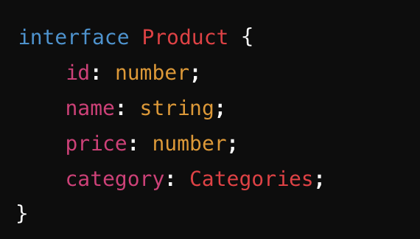

Add Type Annotations



Change it to:



Update the functions:



Change them to include types:  


Do the same for the other functions:



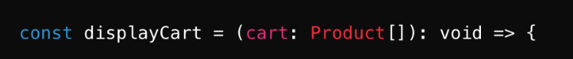

When you are done, you can type: tsc shoppingCart.js.   
  
If everything is correct, the TypeScript compiler will create a new shoppingCart.js file for you that you can use just like before.